Part 1: Official Transcript. Due to payment problems, I wasn’t able to get a copy of my transcript.

Part 2: Degree Sheet

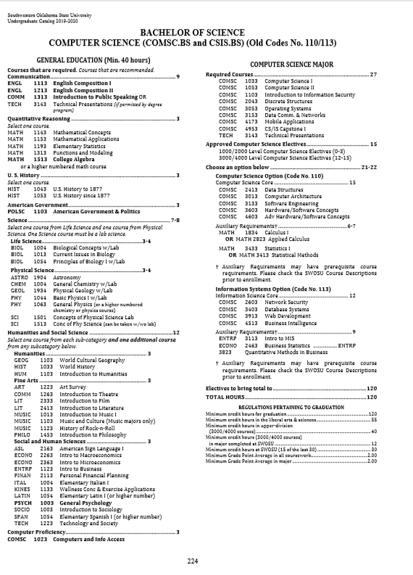

Part 3: Personal Degree Plan.

|  |  |  |  |  |  |  |  |
| --- | --- | --- | --- | --- | --- | --- | --- |
| **Completed** | **Spring 2020** | **Fall 2020** | **Spring 2021** | **Fall 2021** | **Spring 2022** | **Fall 2022** | **Spring 2023** |
|  |  |  |  |  |  |  |  |
| ENGL 1113 | COMSC 1053 | COMM 1313 | GEOL 1934 | COMSC 2413 |  |  |  |
| ENGL 1213 | COMSC 2043 | HIST 1053 | BIOL 1013 | COMSC 3013 |  |  |  |
|  | COMSC 4173 | COMSC 1103 | HIST 1033 | COMSC 3133 |  |  |  |
|  |  | COMSC 3053 | COMSC 3153 | COMSC 3603 |  |  |  |
| MATH 1513 |  |  | TECH 3143 |  |  |  |  |
|  |  |  |  |  |  |  |  |
| POLSC 1103 |  |  |  |  |  |  |  |
|  |  |  |  |  |  |  |  |
|  |  |  |  |  |  |  |  |
| ART 1223 |  |  |  |  |  |  |  |
| PSYCH 1003 |  |  |  |  |  |  |  |
|  |  |  |  |  |  |  |  |
| COMSC 1023 |  |  |  |  |  |  |  |
|  |  |  |  |  |  |  |  |
| COMSC 1033 |  |  |  |  |  |  |  |
|  |  |  |  |  |  |  |  |
|  |  |  |  |  |  |  |  |
|  |  |  |  |  |  |  |  |

Part 4: Resume.

**BRANDON BARDWELL**

BB

[brandonbpcyt@gmail.com](mailto:brandonbpcyt@gmail.com) | (580) 374-8552

2204 N Van Buren Ave, Elk City, OK 73644

# PROFESSIONAL

**SUMMARY**

I am an advocate of happy customers no matter how many there may be I have a background of computer knowledge including but not limited to: Graphic Design, Hardware Solutions, Hardware Management, Software Navigation.

As well as Photography and Photo Editing for banners and advertisements.

# SKILLS

**WORK HISTORY**

Customer service Customer engagement Product promotion Telephone etiquette Point of sale knowledge Communication Hospitality

Food and kitchen safety Order delivery practices Cash handling Beverage preparation

**Crew Member** | Arby's - Elk City, OK

Stocking and replenishing Verbal and written communication Communication skills Table setting knowledge Food running

Food preparation

Teamwork and collaboration Point-of-sale transactions Ordering procedures

Menu memorization

06/2018 - CURRENT

Adhered to company safety standards, including Safety First and Sanitation procedures.

Utilized all machinery and equipment while observing various safety precautions and practices.

Monitored dining rooms for seating availability, service, safety and well-being of guests.

Recorded temperature of food and food storage areas, including freezers and refrigerators.

Weighed and labeled products.

Stored food in designated containers and storage areas to increase shelf life and prevent spoilage.

Relayed orders to bar and kitchen by quickly and accurately recording guest selections and keying them into the register.

4 years retail experience.

Bussed, cleared, cleaned and set tables in quiet and efficient manner. 3 years stocking experience.

Assisted in cashiering and Point of Sale (POS) system procedures during busy hours.

Guided guests through menus while demonstrating thorough

Part 5: Dream Job

My dream job is to be a photographer and a free lance programmer. I know that programmers can make anywhere from 78,000 to 91,000. Photographers can easily make six figures if they have the right marketing.

Part 6: Gap Analysis.

Right now, I am an Animal Control Officer for the Weatherford Police Department. This is the perfect job for me currently because it works well with my college schedule and I am not overworked. Once I graduate is when I will try to work towards what my degree will open for me.

Part 7: Project Description.

This semester I am taking only computer classes to help further my knowledge in programming and hopefully throughout the semester I would be able to start working on freelance projects on the side.